Harris jayakumar V

22ISR013

# Introduction

* This document provides a comprehensive guide on using Git Bash for DevOps practices.
* Git Bash is a command-line interface that allows users to interact with Git repositories and perform version control tasks efficiently.
* The following sections will outline the procedure for setting up and using Git Bash

# Procedure (Working Steps and Commands)

* **Installation of Git Bash**
  + Download the Git Bash installer from the official Git website.
  + Run the installer and follow the on-screen instructions to complete the installation.

# Setting Up a New Repository

* + Open Git Bash.
  + Navigate to the desired directory using the command:
    - cd /path/to/your/directory
      * Initialize a new Git repository:
      * git init

# Cloning an Existing Repository

* To clone a repository, use the command:

git clone <https://github.com/username/repository.git>

# Adding Files to the Repository Add files to the staging area:

git add filename.txt

# To add all files:

git add .

# Committing Changes

Commit the changes with a message:

git commit -m "Your commit message"

# Pushing Changes to Remote Repository

Push the committed changes to the remote repository:

* git push origin main

# Pulling Changes from Remote Repository

* To update your local repository with changes from the remote:
* git pull origin main

# SCREENSHOTS:

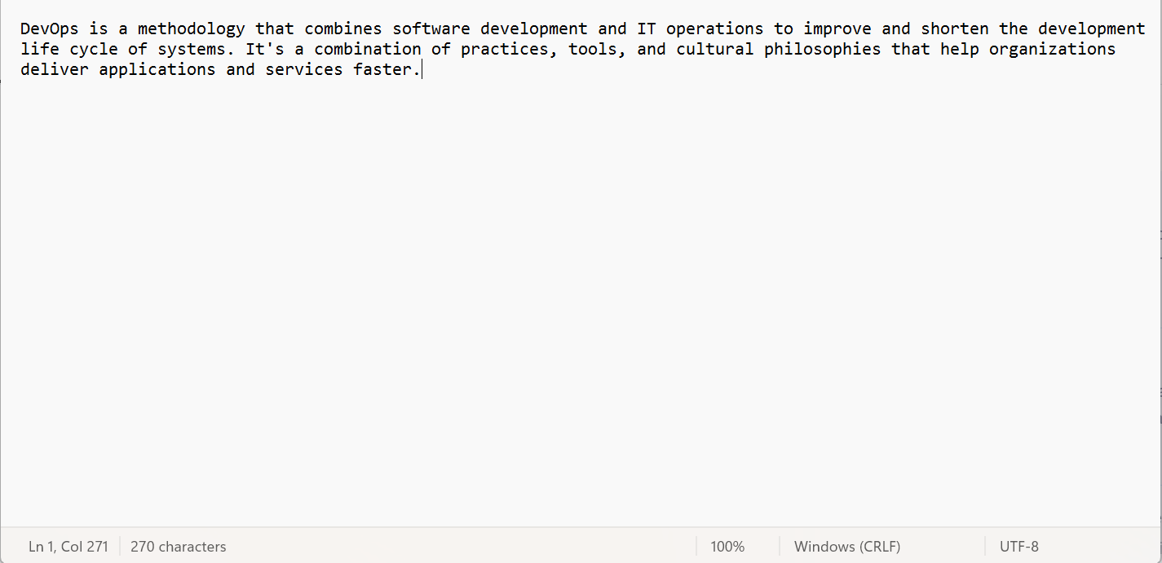

**Creating a directory**

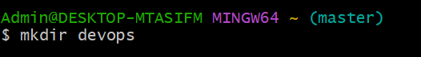

**Changing the directory**



# Initializing a New Git Repository

* Demonstrates the command used to initialize a new Git repository in a specified directory.

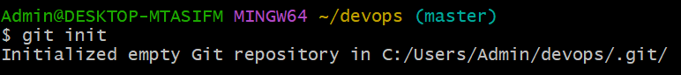

# Creating a text file



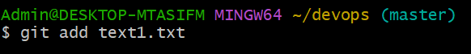

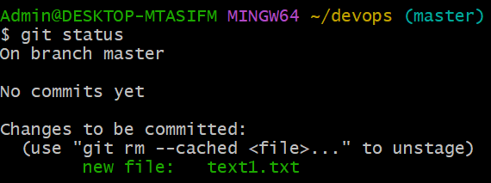

**Adding Files to the Staging Area**

* The process of adding files to the staging area before committing changes.

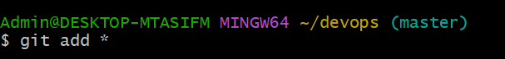

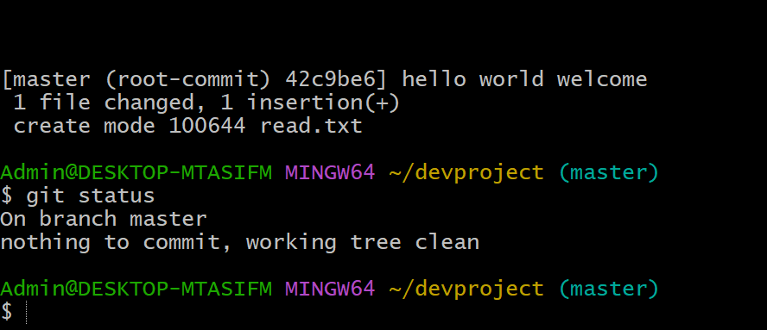

This command sets the global Git username , which will appear in the author metadata for all commits.

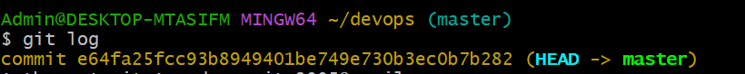

The git status command displays the current state of the repository, including branch information and any changes to be staged, committed, or tracked.



The git status command confirms that the repository is clean with no changes to commit or track.

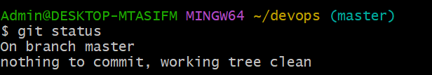

# Switching to the branch

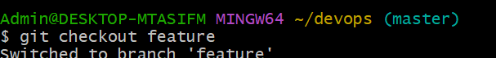

The **git checkout** command is used to switch branches, create new branches, restore files to a specific state, or check out a specific commit in a Git repository.

**Conclusion**

Git Bash is a powerful command-line tool for version control and collaboration. This document covers installation steps and essential commands for managing repositories. Mastering these commands enhances productivity and teamwork, and users are encouraged to explore advanced features for optimized version control.